**Mobile Testing Notes**

**Manual and Automation testing tools**

**There are many approaches/ways to crack something, just think logically, think up, down, left, right, positive, negative, forward, backward.**

**Review, Re-learn, Re-Visit, Rewind and slow the voice on video tutorials. Use images for visual learning on google search.**

**Plan – (Mind Map diagram)**

**ALWAYS REVIEW**

**Understand the word AUTOMATION/AUTOMATING**

**LEARN TO UNDERSTAND AN FOLLOW INSTRUCTION/RECIPE/ALGORITHM TO COMPLETE A TASK. Ask question if you don’t understand for clarity.**

**Programming language is same as English language, pay attention the English syntax order and translate it to that programming language.**

**Custom and Open-Source frameworks.**

**Consistently PRACTICE that one thing over and over again, pick one thing and check it again!**

**Check Mobile testing interview questions and do mobile testing projects.**

**Basic automation tools setup.**

* **JDK, SDK tools only or Android studio ide, Nodejs, IDE, install Appium desktop Gui client/ Appium non-Gui client,**
* Hybrid, Native (calendar, Camera, calculator) and Web (chrome, firefox) Mobile apps.
* Chrome://inspect (if it a hybrid app, it does not work for native app)
* Mobile app testing tools like Appium, Robotium, Selendroid and many more.
* Emulator and Simulator.
* Windows, Android and IOS vendors operating systems platforms AND their versions.
* **Lookout for Software versions.**
* **Client Server architecture.**
* **Appium client and Appium server (Node.js HTTP Server).**
* .**apk and. ipa applications packages.**
* **Appium inspector** client and Appium commands, **Appium** **doctor** (Used to diagnose and fix common Node, IOS, and Android configuration issues before starting Appium, A tool to check if all Appium dependencies are downloaded). **It is used to check or verify Appium installation and it dependencies**.
* Android SDK.
* Selenium extended mobile libraries.
* Our scripts are converted to **HTTP** rest request.
* UIAutomator2 – android driver.
* Windows – WinAppDriver.
* Appium design patterns.
* Appium client Libraries – java, c#, javascript, python.
* Webdriver JSON wire protocol converts requests from the Appium client to HTTP REST format.
* **Desired capabilities** are configuration setting using a set of key-values to tell the Appium server what kind of automation **session** the client is interested in starting up.
* **Autograntpermission for hybrid apps with older android version (google it).**
* **ADB** – Android Debug Bridge command-line tool (ADB client, deamon ADB Server).
* **Headed Mode (GUI) and Headless mode (non-Gui) using chromeoptions**.
* **Technical (programmers (Non-GUI)) and non-technical (Gui) end-users.**
* **Server-side API’s like nodejs.**

Mobile Testing – Mobile applications (CONSISTENCY over MOTIVATION)

Software Test Automation

Every software has a documentation – find it.

**Access information contents through -> Reading textbooks, view images, watch Videos - > Hands-on practical exercises – Come up with a problem and Build/Develop to solve the need.**

**BUILD ALL KINDS OF PROJECTS – LEARN OTHER DEVELOPERS PROBLEM SOLVING LOGIC.**

**Learn the software technology.**

**Problem Solving Skills (Functionality, Object/Program inputs, process – output, storage) – Algorithm (step by step pseudocode, flowchart) – implementation - maintenance.**

**Understand the problem and the object inputs and outputs.**

**Understand the theoretical knowledge concept, implement hands-on exercises – Apply to a problem.**

**Specification and Requirements – business needs.**

**CLIENT SERVER ARCHITECTURE**

**Nth tier layer architecture**

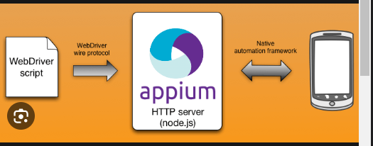

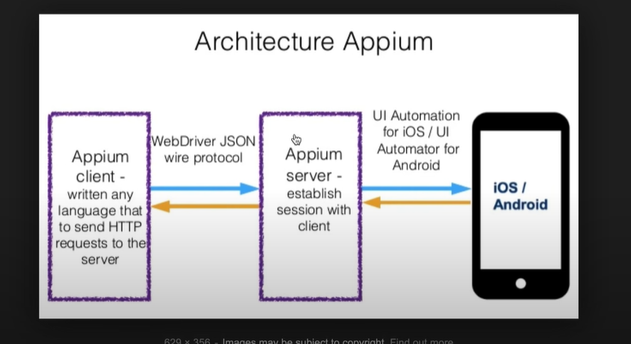

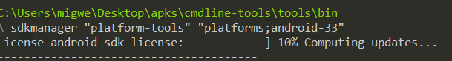

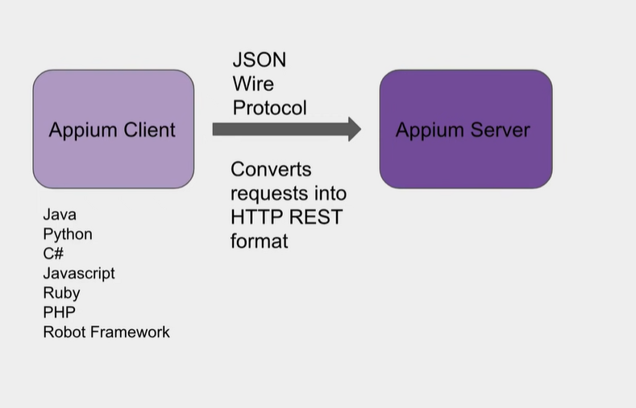

**Mobile Applications**

* **Native app, Hybrid app, Web app, windows desktop app, tizen app.**

**Appium Support platforms**

* Android, IOS, Window, operating system, and apps
* **Take note of the Operating systems versions.**
* Network Testing – offline mode
* Other open source tools like Xamarin, expresso, Robotium, Selendroid.
* Different network 2g,3g, 4g, 5g
* WIFI and Mobile Data network
* Network switching (GSM to WIFI and vice versa)
* Camera and GPD testing.
* Touch, Gesture, Sensors, Orientation.
* Physical and simulator - emulator devices
* **ADB command line program – get and switch the url location of the emulator binary file In the android SDK, e.g C:\Users\migwe\AppData\Local\Android\Sdk\emulator**
* **Enter in the command-line emulator commands – emulator -list-avds, emulator -avd “the name of the virtual emulator device”.**

**appPackage and appActivity**

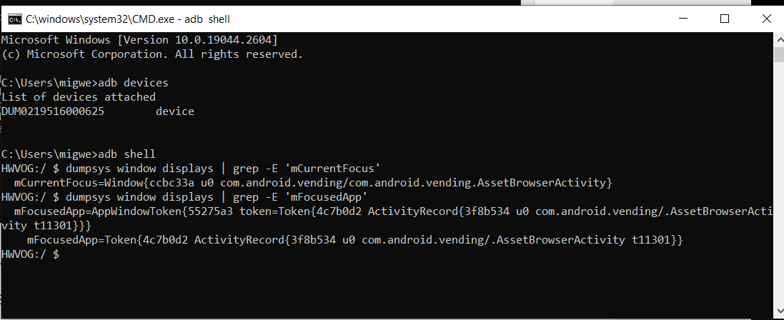

Interruption Management Testing

* Alarms
* Push Notifications
* Messages / sms
* Multi-tasking

Location Testing

* GSP implementation.

Mobile Automation Testing

* Software automation testing tools – Appium, Robotium
* Android driver uses UIAutomator2 driver client/server.
* IOS uses UIAutomation driver client/ server.

Performance Testing – Non-Functional

* Load test
* Stress test
* Response time

Functional Mobile Testing

* Testing the business logic in the application.
* Validating the business requirements based the specification and testcases.
* Exploratory testing.
* Installation and Uninstallation Testing

**(Master this skill) - LOGICAL SEQUENCIAL OREDERING OF WORKFLOW**

Types of Software end-users use to complete their daily task.

* System software program – Operating systems, Network OS
* Application Software program. GUI software programs, UI – Application Programming Interface, Command-line programs

Job Description Details Job Title: Mobile QA Engineer Job Description:

• Define and implement test automation strategy including roadmap, tools, framework & approach.

• Implement, maintain and improve test automation frameworks

• Actively work with development and infrastructure teams for integrating test automation as an integral part of Continuous delivery pipeline

• Provide leadership, guidance, training and mentoring to implement test automation within the Mobile Team

• Pro-actively seek to make continuous improvements to test coverage, execution and automation

• Evaluate, select and formulate best usage of test automation tools for different purposes. .

• Conduct manual functional testing of the Mobile App Our Solution:

• Build up the automation test Framework. Requirements:

• Automation using Appium for iOS and Android platforms

• Appium for automating Mobile Apps • Proven experience in defining and operationalization of test automation strategy

• Proven experience in creating and implementing test automation frameworks for large-scale systems in agile development environment

• Hands-on test automation experience, in a professional software development environment • In-depth knowledge of a variety of testing techniques and methodologies

• A solid understanding of test-driven development, continuous integration, continuous delivery both in principle and in practice

• Expertise of agile and waterfall testing methodologies

• Experience in both Unit and Integration testing needs with exposure to data virtualization tools.

• Experience in several test automation frameworks, e.g., **Selenium, Appium** • Experience with Report Portal for reporting purposes

• Demonstrated experience developing high quality test strategies and test execution specific focus on cross browser/OS and cross device testing.

• Ability to create good acceptance and integration test automation scripts and integrate with Continuous integration and code coverage tools to ensure 80% or higher code coverage.

• Excellent organization, communication, and interpersonal skills • Strong analytical and **problem-solving skills** with the ability to work in an unstructured, fast-paced environment

• Strong organizational and problem-solving skills with great attention to detail, critical thinking, solid communication and proven leadership skills - with the ability to lead multiple test paths simultaneously. Technical skills and experience required: • Manual and automation testing.

• Appium – 3- 5 years’ experience

• Understand coding C# -3-5 years

• Selenium - 3- 5years

Skill/Experience/Education Mandatory Skills Manual and automation testing Appium – 3- 5 years’ experience Understand coding C# -3-5 years Selenium - 3- 5years C# Desired Skills E-Commerce Apps Agile SCRUM Skill

Matrix Search Skill Name Level (1-5, 5 being the highest) 1 2 3 4 5 Years Mandatory(Yes/No) Appiumrow toggle 4-5 Years Yes c[#row](https://www.linkedin.com/feed/hashtag/?keywords=%23row) toggle 4-5 Years Yes Automation testingrow toggle 4-5 Years No Seleniumrow toggle 4-5 Years Yes

<https://www.lifewire.com/apk-file-4152929>

<https://www.deeperthanblue.co.uk/the-test-automation-pyramid/>

UI Elements

Package or namespace are nothing but folder structure path to access functionalities or Objects or Programs.

**Test Automation RoadMap – ROI (Return On Investment)**

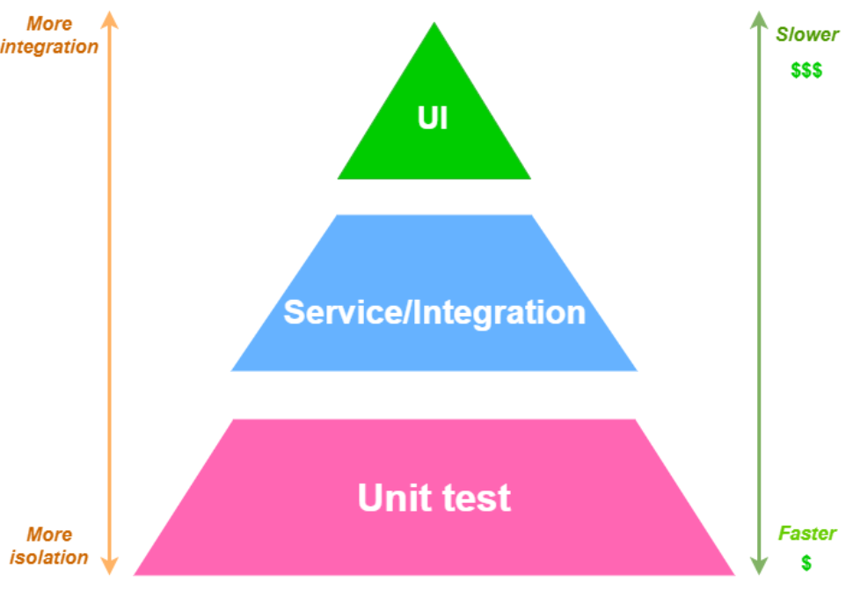

|  |  |
| --- | --- |
| Logical Theoretical Knowledge | Physical Skill and Practical hands-on exercises |
| Textbooks, Visual Images, Videos, discussions | Practicing |

A feature (specific) is a unit of functionality (Program, Object, API, Resource, Entity, Element) of a software system that satisfies a requirement, represents a design decision, and provides a potential configuration option.

